To: Manager, Toronto Wind One Company

From: Bill Chau

Date: Tuesdau, Jul 2, 2019

Re: Toronto Wind One proposal at the Toronto Islands

## Situation

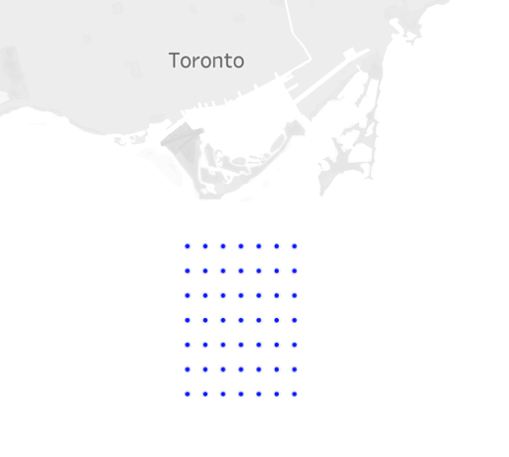The company is studying the feasibility of building a windfarm in Lake Ontario, just south of the Toronto Islands. Toronto Wind One, consists of 49 turbines and each turbine can potentially produce up to 4MW per day.

Figure 1 Potential locations of wind turbines

## Complications

The power output of turbines are subject to weather conditions, most importantly, wind speed. Turbines will not operate when windspeed is under 4m/s and will cut out when windspeed exceeds 32m/s. An ideal location for the windfarm shall have steady wind throughout the day, with windspeed just below cut-out to produce maximum electricity output. Out data team is given the weather data in January, collected at the Toronto Island Airport, to see wether the windfarm produces sufficient power to justify the investment.

## Conclusion and Recommendation

Our team simulated the daily power output of Toronto Wind One based on the weather data in January. According to the specifications of the turbine, the maximum output is 4MW per turbine per hour. Theoretically, each turbine can produce up to a maximum of 96MW per day. The simulation shows that turbines may not produce power output every hour in January, but produced outputs on every single day in January, with each turbine outputs 27.5MW per day on average. The lowest day occurred on January 2 with an output of 1.8MW and the hightest day occurred on Jan 31 with 93.4MW.



Figure 2 Simulated turbine daily output in January

If all 49 turbines were installed and functioning continuously, the company can expect a total of 43,078MW from the windfarm in January. We believe the simulated results are positive, however data is limited to only one month of the year. We strongly encourage the simulation to be extended to study multiple years, or even decades of historical weather data, in order for us to produce more accurate power output estimations.

## Appendix

1. Air density by hour

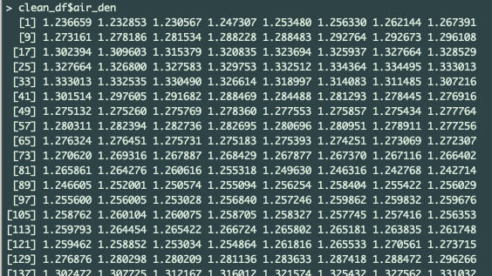

1. Wind speed in m/s by hour

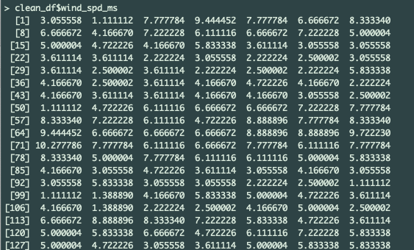

1. Each turbine power output by hour

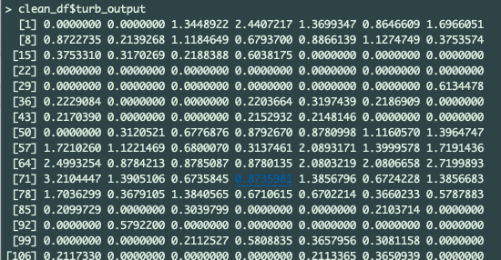

1. Total amount of electricity produced in January in MW



1. Visualization showing power produced per day at windfarm in January

